Task 1 - 2个拿分点

1 - Make comparison 作比较

2 - Summarize the main features 概括主要特点

Type 1 - 动态类 - 找变化(趋势)

题型1 - 动态类 - 曲线图(line chart/graph)

C8-4-1

The graph below shows the quantities of goods transported by four different modes of transport in the UK between 1974 and 2002.

Introduction-Overview(分类-列出有几种变化)-B1-B2(优先选择第一种-第二种的缺点-可能Conclusion的内容跟主体段重复)

Introduction-B1-B2-Conclusion(哪些最大-变化最大-概括最显著的特点)

Introduction ->

(Chart-V-Number-Place-Year) -> 同义替换

* The **graph->line chart** ~~below~~ **shows->displays/illustrates/compares the change in/gives information about** the **quantities->numbers/amounts/volumes** of **goods->cargoes/commodities** **transported->delivered/shipped** by four **different->diverse/various** **modes->means/types/forms** of transport in the UK **between->from** 1974 **and->to** 2002.

由不同的交通模式(Road)所运输的货物数量

-> the **number** of **goods** **transported** by Road

-> the figure for Road

Overview - Road, Water and Pipeline上升(...showed an upward trend) - Rail变化不大(...did not see a noticeable growth)

* **Overall**, the number of goods transported by Road, Water and Pipeline showed an upward trend, **but/while/whereas** the figure for Rail did not see a noticeable growth.

2 requirements - 对比(极值-相似点-不同点) - 概括主要特点(整体趋势)

B1(数量多) - 变化1 - Road, Water and Pipeline上升

Road - 数量最多(...was the largest)(...was the most popular type of transport) - 增长稳定(...increased constantly from 70 to 98/around 100) - 波动(fluctuations)

* **To be specific**, the amount of cargoes delivered by Road was the largest **throughout the entire period**, **and** increased constantly from 70 million tonnes in 1974 to 98/around 100 million tonnes in 2002, although there were fluctuations/despite fluctuations.

The majority of - 一般用在静态类

Eg: the majority of female students preferred to register in Accounting.

Water - 也上升的(the rising trend was also seen in ...) - 先上升-平稳-再上升(... climbed to just under 60 in 1982, **after which** it maintained stable at this level, and hiked again to over 60 in 2002)

* **Meanwhile**, the rising trend was also seen in the volume of commodities shipped by Water, **and it** climbed to just under 60 million tonnes in 1982, **after which** it maintained stable at this level, and hiked again to over 60 million tonnes in 2002.

例子 - 苹果的销量先下降到40吨在1980， 在此之后一直不变，在2000年上升会60吨

The sales of apple dropped to 40 tonnes in 1980, **after which** it maintained stable at this level, **but** increased back to 60 tonnes in 2000.

Pipeline - 数量最少(...was the least popular form of transport)(... was the lowest) - 增长(... surged more than four times from 5 to 23)

**At the same time**, Pipeline was the least popular form of transport to deliver goods, **although the figure for this form of transport** surged more than four times from 5 million to 23 million tonnes.

B2(少数) - 变化2 - Rail变化不大

Rail - 1978之前 - 数量跟Water相似 (... was similar with)- 但是在此之后 - 下降(... declined to 25) - 上升(... grew back to approximately 40)

**In terms of Rail**, the amount of goods transported was similar with that of Water **before 1978 (holding stable at about 40 million tonnes respectively)**. **After that** it declined to 25 million tonnes in 1994, **whereas** grew back to approximately 40 million tonnes in 2002.

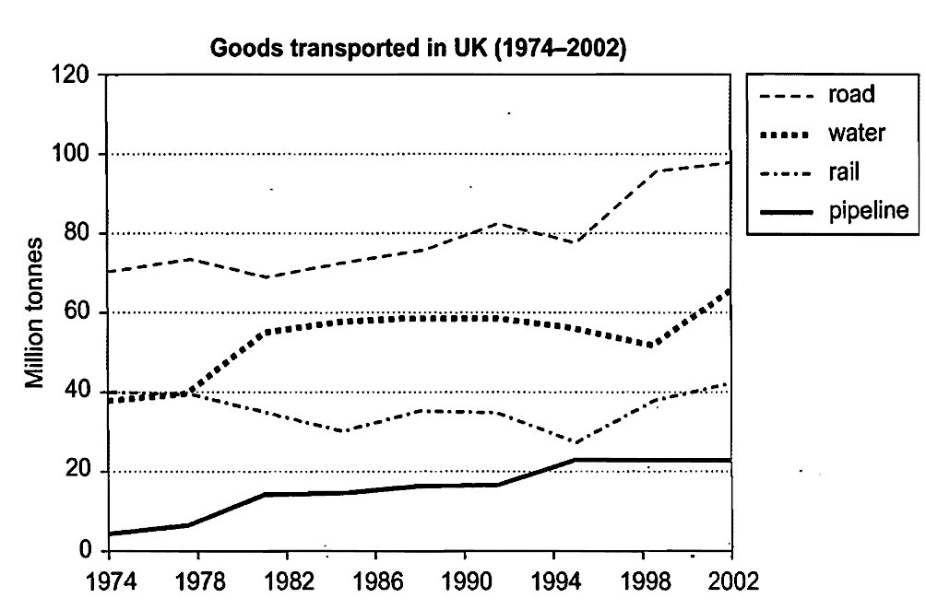

题型2 - 动态图 - 曲线

C11-3-1

The graph below shows average carbon dioxide (CO2) emissions per person in the United Kingdom, Sweden, Italy and Portugal between 1967 and 2007.

Introduction - 题目改写

* The **graph->line chart** ~~below~~ **shows->illustrates** average carbon dioxide (CO2) emissions per person in the United Kingdom, Sweden, Italy and Portugal **between->from** 1967 **and->to** 2007.

在不同国家(UK)人均碳排放量

-> average carbon dioxide emissions per person in the UK

-> the average **emission/release/production/generation/creation** of carbon dioxide per individual in the UK

-> the average **number/quantity/amount/volume** of **carbon dioxide/greenhouse gas/glasshouse gas** per person **produced/made/created/generated/emitted** by UK

-> the figure for UK

Overview - 分类 - The UK and Sweden下降(... witnessed a decline) - Italy and Portugal上升(... showed an upward trend)

**Overall**, the prodution of carbon dioxide in the UK and Sweden witnessed a decline, **but** the figure for Italy and Portugal showed an upward trend.

B1 - 变化1 - The UK and Sweden下降

UK - 一直最大的(... was the largest)(... was the largest producer of carbon dioxide among four countries) - 尽管稳定下降(... decreased steadily from 11 to 8.5)

**To be specific**, UK was the largest producer of carbon dioxide among four countries throughout the entire period, **although** the emission decreased steadily from 11 tonnes in 1967 to 8.5 tonnes in 2007.

Sweden - 也下降(the downward trend was also seen in ...) - 先上升后下降(... dropped dramatically from 8.5 to 5.5, despite fluctuation)

**Meanwhile**, the downward trend was also seen in the number of CO2 produced by Sweden, **and it** dropped dramatically from 8.5 tonnes in 1967 to 5.5 tonnes in 2007, despite fluctuation.

B2 - 变化2 - Italy and Portugal上升

Italy - 相反的趋势(there was an opposite trend in ...) - 稳步上升(... climbed gradually from about 4 to 7.5)

**In contrast**, there was an opposite trend in the generation of CO2 in Italy, **and it** climbed gradually from about 4 tonnes in 1967 to 7.5 tonnes in 2007.

分数更高 - 句式更多样 - 描述更加接近图像

Italy - 排第三的(...ranked third) - 上升(climbed完成时) - 1987超越Sweden(overtook ing形式)- 变成第二(after which 句式)

**As for Italy**, the emission ranked third during the initial two decades, **and** had climbed steadily since then, **overtaking that of Sweden in 1987**, after which Italy became the second largest producer of this kind of greenhouse gas.

Summarize the main features

Portugal - 一直最小(... was the lowest, with 1.5 in 1967) - 增长(... surged to 5.5 in 2007 (similar with the figure for Sweden))

**At the same time**, the amount of CO2 in Portugal was the lowest, with 1.5 tonnes in 1967, **although it** surged to 5.5 tonnes in 2007 (similar with the figure for Sweden in the last year).

作业 - 动态图 - 表格

The table below gives information about changes in modes of travel in England between 1985 and 2000.

Introduction-Overview-B1-B2

特点相似的一起写

变化1 - 上升

变化2 - 下降

Type 2 - 静态类 - 找规律(对比)

题型1 - 静态 - 两组对比

The chart below contains information provided by Australia’s tertiary institutions about the percentage of male and female students who enrolled in different subjects in 1995.

规律1 - Female>Male - 对应科目

规律2 - Male>Female - 对应科目

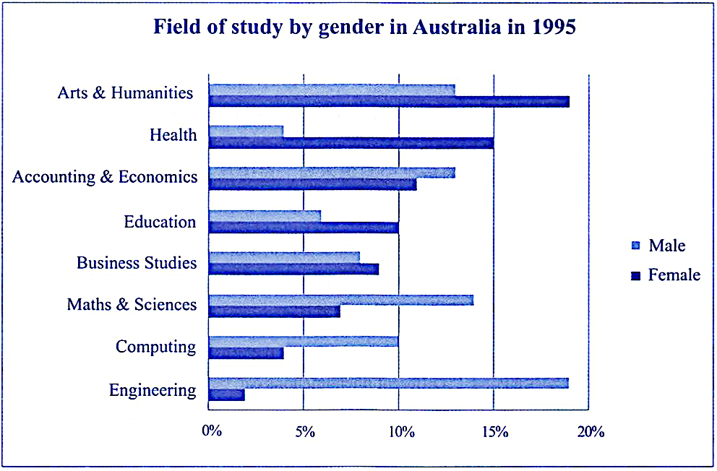

题型2 - 静态类 - 三组对比

规律1 - C>A>B - hospital staff

规律2 - C>B>A - waiting time

规律3 - A>C>B - other services

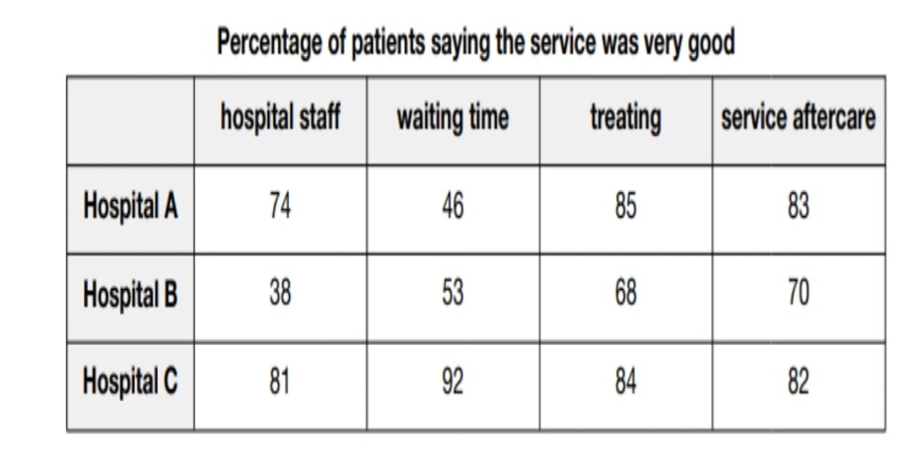

Task 2 - Requirements

Task Respond - 不离题(开头提到关键词) - 适当回应题目(每段都有提到关键词) - 积极回应题目(每一句拓展都在围绕关键词展开)

Coherence(连贯性-连词-逻辑词-代词-内容拓展make sense) and Cohesion(内容围绕一个Topic展开)

Cohesion: 做...能促进社会进步 -> 科技进步 - 经济发展 - 消除贫穷...

Lexical resource - 词汇储备 - 用词恰当 - 同义替换

Grammar range and accuracy - 准确且多样

SWOP模型

Strength优势 - Threat威胁

Weakness缺点 - Opportunity机会

题型1 - Do you agree or disagree?

## Pay Tax

Some people believe that they should be able to keep all the money they earn and should not pay any tax to the state.

To what extent do you **agree** or disagree? 态度：应该交税 - 但是税率应该在合理的范围

Introduction - 改写 + 态度

A proportion of taxpayers argue that it is unnecessary to pay their tax to the government. **However**, I disagree with this viewpoint/I hold an opposite viewpoint. (22 words)

B1 - 交税的好处 - 构建公共设施(效果/目的) (提高人民的生活幸福感)- 减少贫富差距

交税pay tax-为什么可以建设基础设施(政府有钱了tax revenue) 有钱去做某事more funds could be allocated to...-> 构建公共设施construct public facilities-(提高人民的生活幸福感increase the well-being of the masses) - 为什么建设后人民就幸福了(交通的完善transportation system could be improved-减轻塞车traffic jams/congestion could be also eliminated/mitigated/minimized-提高通勤者的出现体验commuters would find it more convenient to travel to and from work ) - (博物馆-图书馆的普及the popularity of museums and libraries-可以开拓视野broaden citizens’ horizons-感受历史和学习知识的乐趣enjoy the fun of experiencing histories and acquiring knowledge) - 如果没有税收if governments have no tax revenue(人民大概率无法接触到这些设施的便利these facilities will be unavailable for the public)

**To begin with**, I strongly believe that it is necessary to ask the public to pay tax **because** if governments have tax revenue, more funds could be allocated to construct public facilities, which can increase the well-being of the masses. **For example**, with adequate budget, transportation system could be improved and traffic jams/congestion could be also eliminated/mitigated/minimized. **As a result**, commuters would find it more convenient to travel to and from work. **Meanwhile**, the investments on educational facilities can also promote/facilitate the popularity of museums and libraries. **It** can provide more opportunities for citizens to broaden their horizons and enjoy the fun of experiencing histories and acquiring knowledge. **Conversely/However**, if governments have no tax revenue, these facilities will be unavailable for the public. (123 words)

B2 - 交税的风险(特定情况下) - 比如税率太高high tax rate - 负面影响have a negative impact on the society - 居民可支配收入降低residents’ disposable incomes will decline - 增加生活压力pose a financial pressure/burden on them - 特别是预算紧张的家庭especially those families who live in a tight budget - 降低工作积极性decreased the motivations/incentives of taxpayers to work hard - 社会的总体产能会降低the productivity of the whole society will also drop - 社会不会繁荣the society will not thrive/flourish/prosper - (77 words)

**On the other hand**, **we can not rule out the risk that** high tax rate will have a negative impact on the society. **It means that** if residents were subject to heavy tax, their disposable incomes will decline. **Consequently**, it will pose a financial pressure/burden on them, especially those families who live in a tight budget. **The following/subsequent negative effects on the society will be that** it will decrease the motivations/incentives of taxpayers to work hard, the productivity of the whole society will also drop and the society will not thrive/flourish/prosper. (91 words)

Conclusion - 应该交税 - 但是税率应该在合理的范围

**In conclusion**, it is essential to pay tax, **while** governments should make sure that the tax rate is reasonable.

题型2 - Do you think this is a positive or a negative development?

类型题目：Do you think it is a positive characteristic to achieve success?

## Population Movement

In many countries around the world, rural people are moving to cities, so the population in the countryside is decreasing.

Do you think this is a positive or a negative development?

SWTO 站在谁的立场 - 分析利弊

Introduction - 题目改写 + 立场(20 words)

**In many parts of the world**, rural residents are migrating to urban regions**. In my opinion**, this phenomenon/development/trend/demographic change is positive.

B1- 迁徙者 - Strength(employment) - 更多就业机会access to more job opportunities - - 补充其他方面的好处(更多的工作类型-实现自我价值) - 赚更多的钱increase their income/ earn more money - 更好的生活条件improve their living standards - 对比-这些就业机会几乎的没有的these working chances are normally unavailable/scarce-很多公司都集中在城市或者市郊the majority of companies mainly locate in city centers and suburbs-为了更高的购买力和更便捷的交通in search of higher purchasing powers of urban inhabitants and more accessible transportation system - 曾经住在农村的父母those parents who used to live in countrysides也会选择把孩子送到城市often intend to sent their children to cities去接受更好的教育to receive better education - 提高就业前景increase their children’ employment prospects -

**To begin with**, the settlement in cities enables these new comers to access to more job opportunities. **It means that** they are able to increase their income and improve their living standards. **By comparison with the rural areas**, these working chances are normally unavailable/scarce due to the fact that the majority of companies mainly locate in city centers and suburbs in search of higher purchasing powers of urban inhabitants and more accessible transportation system. **At the same time**, those parents who used to live in countrysides often intend to sent their children to cities to receive better education, believe that it can increase their children’ employment prospects. (107 words)

B2 - 农村地区 - Threat(the economic development in rural regions) - 过量的人口迁徙the population shift from rural to cities - 劳动力短缺a shortage of workforce - 农村发展不好underdevelopment- 很多对地区经济重要的产业many industries essential/vital to one’s economy包括农业和工业including agriculture and manufacture都依赖密集的劳动力rely/depend heavily on dense labors - 如果缺乏足够工人if there are less sufficient farmers and workers - 这些产业就会流失it will cause the lost of these industries - 农村经济发展缓慢rural economy will be less likely to thrive/flourish - 加大地区之间的贫富差距broaden/widen the economic gap between rural and urban regions(93 words)

**On the other hand**, it is inevitable that the constant population shift from rural to cities will eventually result in a shortage of workforce, which can cause the underdevelopment of rural regions. **To be more specific**, many industries essential/vital to one’s economy including agriculture and manufacture rely/depend heavily on dense labors. **In case where** there are less sufficient farmers and workers in rural regions, it will cause the lost of these industries. **The prospective consequences will be that** rural economy will be less likely to thrive/flourish and it broaden/widen the economic gap between rural and urban regions. (97 words)

Conclusion - 立场(B1B2) - 对迁徙者migrates来说可以提高工作的可能性increase their possibilities of employments - 但是过渡人口迁徙the excessive migration can have a detrimental effect on the rural economy就会对农村的经济发展带来不好的影响

**In conclusion**, the population movement to cities can increase migrates’ possibilities of employments, **but** the excessive migration can have a detrimental effect on the rural economy. (26 words)

1. Prospect 前景 - adj. prosperous繁荣的 - prospective 预期的

城市地区 - 大量廉价劳动力 - 促进工业的发展 - 城市就会发展更繁荣

城市本地人 - 就业压力变大 - 失去工作 - 收入降低

题型3 - Do the advantages outweigh the disadvantages?

## Vehicle-Free days 限行日- Environment

Some cities have vehicle-free days, when private cars, trucks, and motorcycles are banned from the city center. Public transportation like buses, taxis and metros are advised. To what extent do you think the advantages of this outweigh the disadvantages?

SWOT

Introduction

Strength实在的(topic) - 缓解市中心的环境污染 - 空气污染 - ...

Threat潜在的(带来不便利) - 高度依赖私家车或者鬼火出行的人-出现受到限制 - 在市中心的公司-无法在Vehicle-free days使用卡车-运输效率下降-影响公司的发展 -

Conclusion

拿分点 - 积极回应题目 - 每段咬定一个topic来拓展

语法和词汇就看个人努力

(if x>1 bad - if x<1 good)

Screen time - Learning

Voluntary service - Acquire social skills